IS MALE MORE DIFFICULT THAN FEMALE TO GET ADMITTED INTO TOP UNIVERSITIES

Xin Tang

Bellevue University

Abstract

In lieu of recent fair admission lawsuit against Harvard University's undergraduate admissions process, which is claimed to discriminate against Asian American applicants, There is another common impression in Asian community that males are more difficult to get admitted into top university than their female peers, this study is intended to validate if this is a true statement, by using data from top level universities, including those from Ivy Leagues and some other commonly acknowledged top schools.

Keywords: college admission, male, female.

GENDER FACTOR ON COLLEGE ADMISSION

# INTRODUCTION

Westwood high school, which my kids are attending, is the most competitive school in the city. Every year there are quite a few students who get admitted into Ivy school, or, if affordability is a concern, the top public university. In 2022, all top 10 have been admitted into the top 50 ranked US universities, including MIT and Harvard, all will study in STEM track. Among these 10 students, Male to Female ratio is 6:3. This stands out when considering the male /female student ratio in this school is even. On the other hand, there is also a common impression that, due to gender balance/diversity concern, female students, who are at similar academic level and background, are more likely got admitted in than male students. From the neighborhood I lived in, I had heard 5 girls living close by got admission to top universities in 2022, all taking computer science major, but I hardly heard any news related to boys. So, I am interested in exploring more on this topic.

## Overview of the topic:

To answer the question: “is male more difficult than woman to get admitted into top universities?” I need to turn the question into some more searchable questions. Here are a few questions I am trying to find answers:

* + Is there any google search in male/female admission?
  + Is there any search trend in gender-based admission discrimination?
  + What is the male to female ratio in Westwood high school?
  + What is the male/female undergraduate enrollment ratio in Harvard?
  + What is the national gender-based admission rate?
  + What are the data resources I can use?

**Assumptions before research:**

For the benefit of narrowing down the topic, I placed the following conditions / assumptions to my research:

* + Only the top 50 universities will be considered, since these schools are very selective, and the students enrolled are equally good. I will try to use Ivy school or equivalent first, other schools will be used only if Ivy school do not have data.
  + Literature school and woman only school will be excluded as well, since they are naturally female heavy.
  + If possible, I will drill into engineering schools in these universities since the engineering school are traditionally male dominating.

## Analysis:

## The first step is to search online for existing News reports or research articles related to gender impact on admission. I used several key words like “gender biased admission,” “sex biased admission,” “gender discrimination” or “gender factor in college admission.” The searches yielded several new reports, including one from US news, details are included in the reference section.

Second, I searched online for all Ivy schools for their class 2026 admission male/female ratio. I also included some other prestigious schools like Stanford, Texas Austin and Rice university, since they are the dominating top schools for their states, The results are listed in the section below.

Third, for schools I could get more data into specific majors, I will drill into data to get more details. I can find detailed data from MIT, which is also mentioned in several News reports for gender bias.

## Preliminary findings:

Even though there are searches on gender factors on admission, there are many more searches on fair admission than gender factor. This could be an indication that gender may not be commonly concerned as race. At the same time, Harvard and several other top schools did admit more female student than male student in class 2026. At the same time, I come across an interesting finding that much more female student continue pursue the college degree than male. So, while female is dominating the undergraduate admission, this fact may not be due to discrimination or university intention, but due to some other factors, like more male students decide not to continue college education, but to start working after high school graduation. This needs to be explored more using more data and finding more facts.

## Further Findings:

The result is interesting.

From general population aspect, for male/female ratio. US had slightly more (1-2%) female than male consistently in last 12 years. The same is true for Texas. Considering most teens in US can stay in school till high school graduation, that may translate into that more female students than male can be eligible to applying for college, the data from statista.com also supports that.

Looking at data from 13 top schools chosen, it is showing the female students is consistently the majority, if not the same.

However, applying for a top college is different from applying for a general university. Even almost no school release data of their undergraduate applicants based on gender, we can get the picture from a different angle: SAT scores. A data from Brown university indicated that 99% of the applicants is among top 10% of the class. 93% of the applicants achieved 1400 and above SAT score. Data shows almost all Ivy schools require students to have a very high SAT score to get considered. At the same time, Accordingly to Sawyer, “*45 percent more men than women are in the top score range of 1400-1600 in SAT. On the old test, the gender gap at the highest score range was 31 percent*”. So, there must be more males than females students who can meet that criteria. My local high school data also showed more male students reach top 10 ranking,

Using MIT as example, which provided far more admission details than other universities. The common data sheet from MIT showed that, excluding those do not want to disclose the gender, the number of first-year male applicant is 21672, with 665 get admitted, the admission rate is just above 3%. The actual enroll rate (admitted and enrolled) is 91%, that translate to 605 first year male students. At the same time, first year female applicant is 11568 with 700 get admission, the rate is 6%, the actual enroll rate is 86%, which translated to 602 female students. When looking at the engineering school, there are 400 first year female student, which means majority of the 602 admitted females are in that school. The differences, both the applicant gender ratio and admission ratio, are statistically significant. So, applying for MIT is significantly difficult for male student than woman, going into engineering school may even more difficult, Only the high enroll rate on male side helped to prevent MIT from becoming a female school.

Another report from Ivycoach.com disclosed some detail data on Ivy school 2022 admission statistics. I quote one sentence related to Brown university: “*Anyhow, 430 Early Decision admits identify as female, while 308 identify as male. As we’ve reported in the past, Brown tends to admit more students who identify as female than they do male so the disparity in this year’s Early Decision pool should come as little surprise.”*

A year 2016 article from Washington post mentioned that “*of the Top 30 US news national universities, 10 had gender differences of 3 or more percentage points in admission rate*” it is also mentioned that many prominent schools have little or no gender difference in admission rate, with this general conclusion, the article also listed MIT as one of the school most favorable for female with 6 points gaps. Which is proven by year 2022 admission data mentioned above.

It is worthy mention that this article also points out that some colleges, like Tufts favor male applicants. I could not find detail data to support that though.

**More assumptions before drawing conclusion:**

With limited data, I must make some assumptions to draw conclusions:

1. The released data from each university is true and did not tailored for a certain purpose.
2. The data behind Media report is also based on true data and not biased.
3. Top universities are still considering SAT a top factor when selecting applicants for admissions.
4. Only, or, majority students who applies for top universities are with above average academic performance (i.e: SAT score)

**Conclusion:**

After looking at population ratio, the general and the top school's student gender ratio, it is a fact that there are more female students than male in top colleges. It is also true that some top ranked universities, like MIT, have significant better admission rate for female applicants than male applicants. However, the gender gaps could be one way or another, and not always at the same level for all top colleges. It is better for students to investigate their dream school for more details before applying.

**Next Step:**

One piece of information that will help to draw a better conclusion is for more universities to release the gender distribution information, per applicant, per major.

**Ethical concerns**

Diversity and gender balance are sensitive topics for schools. Any research of school admission process on this aspect will bring debate and ethical concerns.

The first concern is that without an agreed baseline, it is difficult to define what is being considered as equal or bias on gender factors, from the public view standpoint. The far-left party may think male and female should be admitted in equal percentage, regardless the factor of student ability or potential. The conservative party may think it is naturally to have more male students than female in college. It is clearly shown that the research may draw different conclusions on the same topics, and same kind of universities.

Second concern is how much school is willing to release related data for public analysis or scrutinize. My research shows almost no school is publishing all the data. Also, the media is not willing to release the data their conclusion is based on.

Third concern is how this topic/concern will change the behavior of students/parents, when choosing majors and schools during colleges application. boys/girls may choose majors based on how easy it is to get admitted in, rather than how they like it. If there is a trend that a student picked a school or major based on its fame and how easy to get it, and then dropped or switched track later because of no interest, it could a waste of personal public resources.

**Challenges/Opportunities**

Since the race related data on college admission is quite sensitive, it is a challenge to get a complete data on the portfolio of the admitted students for each university/college. At the same time, there are great need for this kind of data to get student/parents prepared. This is a great opportunity to work with universities to do some research, get more data and maybe a great business chance for parents willing for pay as well.

References & Sources

Fair admission vs college admission gender search trend – Google trend.

<https://trends.google.com/trends/explore?date=today%205-y&geo=US&q=college%20admission%20gender,fair%20admission>

College admission gender search –Google trend

<https://trends.google.com/trends/explore?date=today%205-y&geo=US&q=college%20admission%20gender>

Harvard College Admits Class of 2026 (Mar-022) - The Harvard magazine

<https://www.harvardmagazine.com/2022/03/harvard-college-class-2026-admissions>#

Westwood high school 2022 top 10 (May-2022) - RoundRock ISD

<https://roundrockisd.org/graduation/top-10/whs-2022-top-10/>

How can Asian American male application standout in admission –Quora

<https://www.quora.com/How-can-an-Asian-American-male-applicant-stand-out-in-college-admissions>

immediate-enrollment-in-college-of-high-school-completers-in-the-us-by-gender

statistica <https://www.statista.com/statistics/478663/immediate-enrollment-in-college-of-high-school-completers-in-the-us-by-gender/>

How gender influence college admission -US News

<https://www.usnews.com/education/best-colleges/articles/2018-11-02/how-gender-influences-college-admissions#:~:text=Among%20the%20478%20ranked%20national,percent%20advantage%20for%20female%20applicants>.

Gender Balancing” as Sex Discrimination in College Admissions - Shayna Medley

<https://harvardcrcl.org/wp-content/uploads/sites/10/2016/10/medley.pdf>

Does gender bias exist in college admissions - UNIGO.com

<https://www.unigo.com/admissions-advice/does-gender-bias-exist-in-college-admissions>

Common data sheet, diversity dashboard and first year admission statistics - MIT

<https://ir.mit.edu/cds-2022>

<https://mitadmissions.org/apply/process/stats/>

<https://ir.mit.edu/diversity-dashboard>

At some colleges. Your gender might give you an admissions edge. -Washington post

<https://www.washingtonpost.com/news/grade-point/wp/2016/03/13/want-an-edge-in-college-admissions-see-the-schools-where-women-and-men-have-an-advantage/>

Gender in college admissions -collegetransitions.com

<https://www.collegetransitions.com/blog/can-your> gender-give-you-an-admission-edge/

2022 Ivy League Admissions Statistics -Ivycoach.com

[2022 Ivy League Admissions Statistics | Ivy Coach](https://www.ivycoach.com/2022-ivy-league-admissions-statistics/)

Male/female ratio on top SAT score

<https://msmagazine.com/2018/02/15/highest-performing-women-still-scoring-lower-men-sat/>

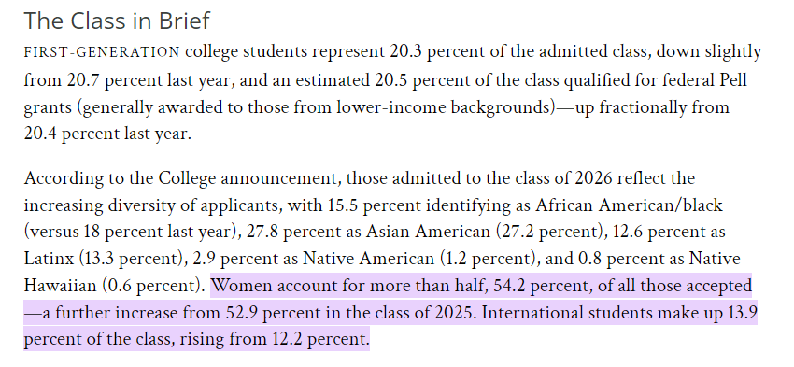

Figure 1. Harvard class 2026 admission diversity

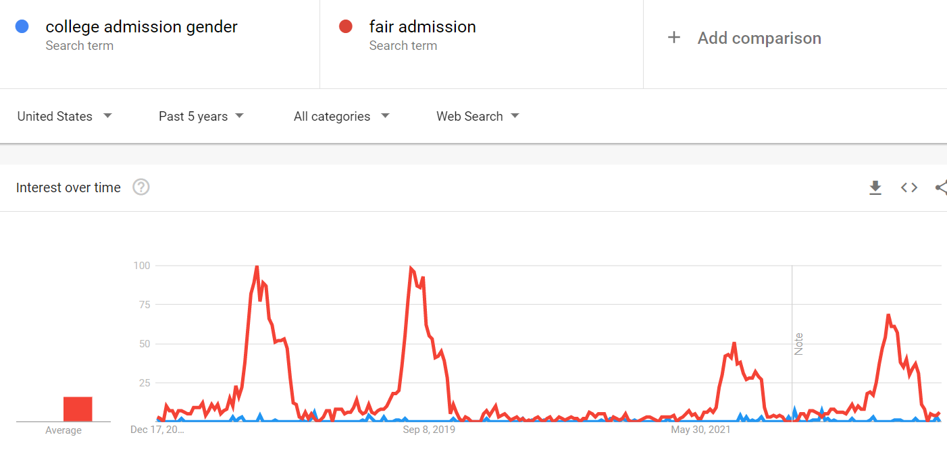

Figure 2. Google trend comparison between fair admission vs gender-based college admission

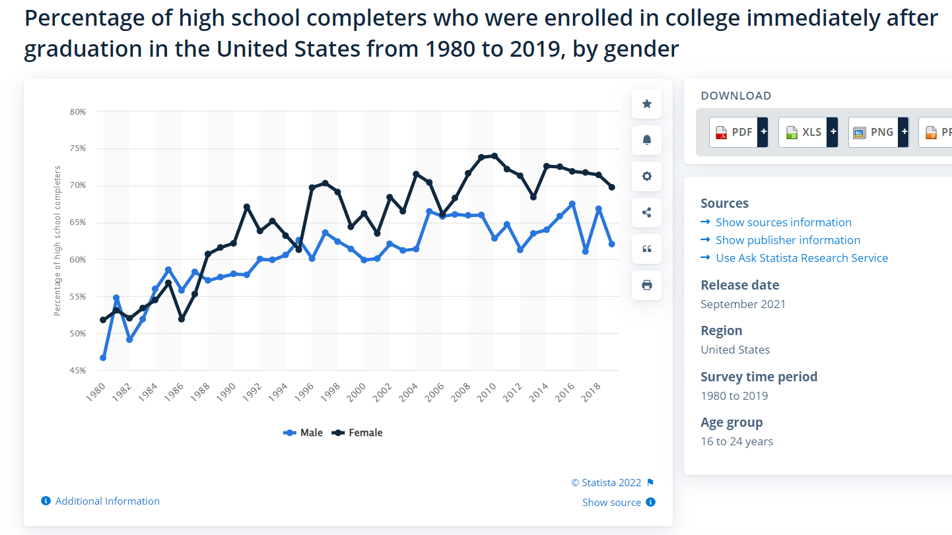

Figure 3. trend of high schooler who enrolled in college right after graduation, by gender

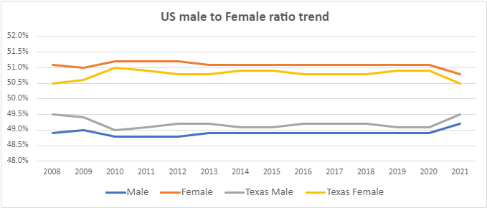

Figure 4. US and Texas male to female ratio trend since 2008 (female is leading 1-2% all time)

|  |  |  |  |
| --- | --- | --- | --- |
| **Ivy League** | **School name** | **Class 2026 male** | **Class 2026 female** |
| Y | **Harvard** | 45.8% | 54.2% |
| Y | **Yale** | 49.0% | 51.0% |
| Y | **Princeton** | 49.0% | 51.0% |
| Y | **Dartmouth** | 49.5% | 50.5% |
| Y | **Columbia** | 49.1% | 50.9% |
| Y | **Cornell** | 45.1% | 54.9% |
| Y | **Brown** | 48.8% | 51.2% |
| Y | **U penn** | 44.0% | 56.0% |
| No | **Duke** | 45.7% | 54.3% |
| No | **MIT** | 48% | 52% |
| No | **Stanford** | 49.0% | 51.0% |
| No | **RICE** | 50.0% | 50.0% |
| No | **UT Austin** | 40.7% | 59.3% |

Figure 5. Top universities male to female student ratio in undergraduate class 2026

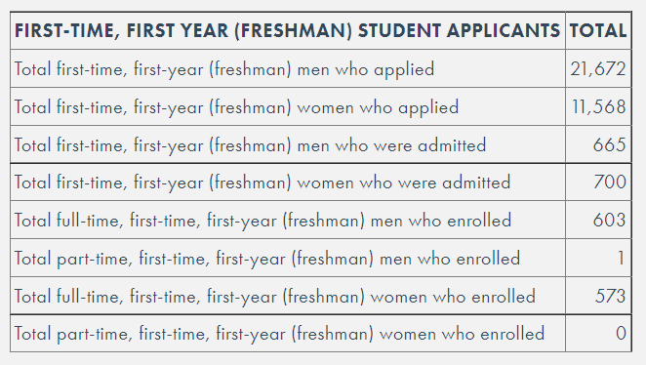

Figure 6. MIT common data sheet showing the male to female applicant and admission count in 2021 undergraduate admission

|  |  |  |
| --- | --- | --- |
| **SAT score of the first year admitted students who submitted SAT score** | | |
|  | **SAP EBRW (700 above)** | **Math (700 above)** |
| **Brown** | 93% with 700 and above in EBRW | 95% with 700 and above in math |
| **Columbia** | avg EBRW is 735 | avg math is 770 |
| **Cornell** | avg EBRW is 715 | avg math is 750 |
| **Harvard** | prefer to score 1515 and above | |
| **Penn state** | middle 50%: 1270 to 1450 | |
| **Princeton** | Milddle 50%: 730-780 | Middle 50%: 760-800 |
| **Yale** | Middle 50%: 720-770 | Middle 50%: 740-790 |
| **Dartmouth** | Avg is 1440-1560 | |
| **MIT** | Average: 750-800 | Average: 770-800 |
| **National Average** | 495 | 511 |

Figure 7. Ivy school admitted student SAT score vs national average.